**REALTIME WEATHER BASED SMART SPRINKLER SYSTEM FOR GOLF COURSE**

**(using random values n weather api)**

**Introduction:-**

***Overview*:-**

In agriculture fields or lawns watering systems such as sprinklers or drip water wires are fitted to feed the plants to reduce human load. Normally sprinkler systems operate with respect to time, which means if we program it on specific time and it will be on even if rain occurs during that particular time. Since water is a precious resource we need to use it very carefully. Here we are proposing an idea of smart sprinkle system where human interaction and automation are combined and at the same time we can measure the values of temperature and humidity. A soil sensor is used which gives the moisture content in the soil. If the moisture content is below particular level the sprinkler systems automatically gets on. We have also integrated current weather report, which can be used to augment the system. Based upon the weather data, watering the plants can be delayed for some time if there is rain prediction in the immediate time.

***Purpose*:-**

By this project one can able to control the water sprinklers in the fields, lawns and grounds at anywhere and any time. By this we can check the temperature and humidity as well as soil moisture content in that places.

**Literature Survey:-**

***Existing problem*:-**

In a field or garden, the person has to move physically to check or know the status of the our garden or field. Sometimes we may not be possible to monitor our garden or field view continuously. If person get damage can't do the thing whicj we want to do for the garden. Person is not available at all the time, if this possible it may be a strain for the person to monitor continuously.

***Proposed Solution*:-**

By using Iot we can able to develop the application which we get details like temperature, humidity, moisture. By this it gives or send the message to the person.

**Theoretical Analysis:-**

***Block Diagram*:-**

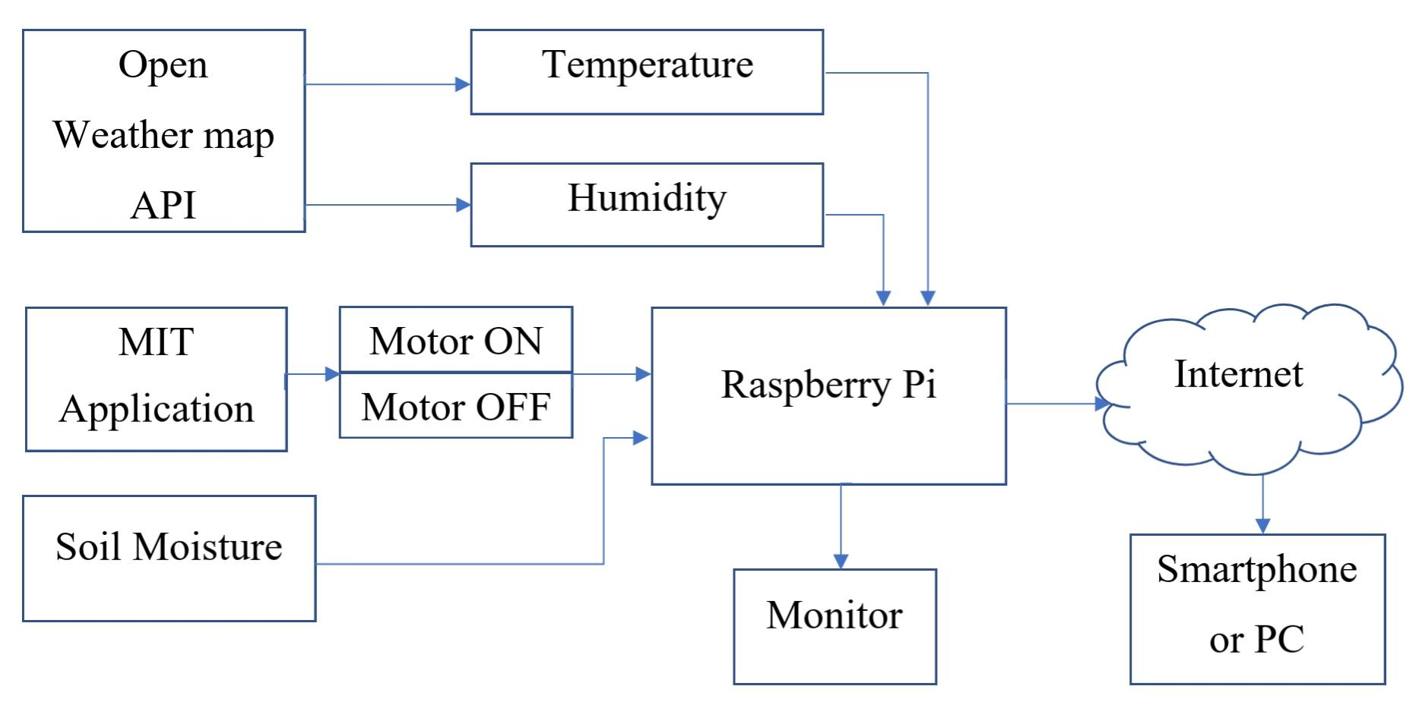Fig-1: Block Diagram

***Hardware/ Software Designing*:-**

The hardware part of the project involves the paspberry pi 3 mode. The sensors are connected to the pi via the I2C interface. The sensors values are ready by the pi, processed ,and then send to the IBM cloud service using the Pi's Wi-Fi module. The data send to mobile application which was developed using MIT app Inventor. Here we use python language for coding. Nodered, etc. Software tools are used.

**Flowchart:-**

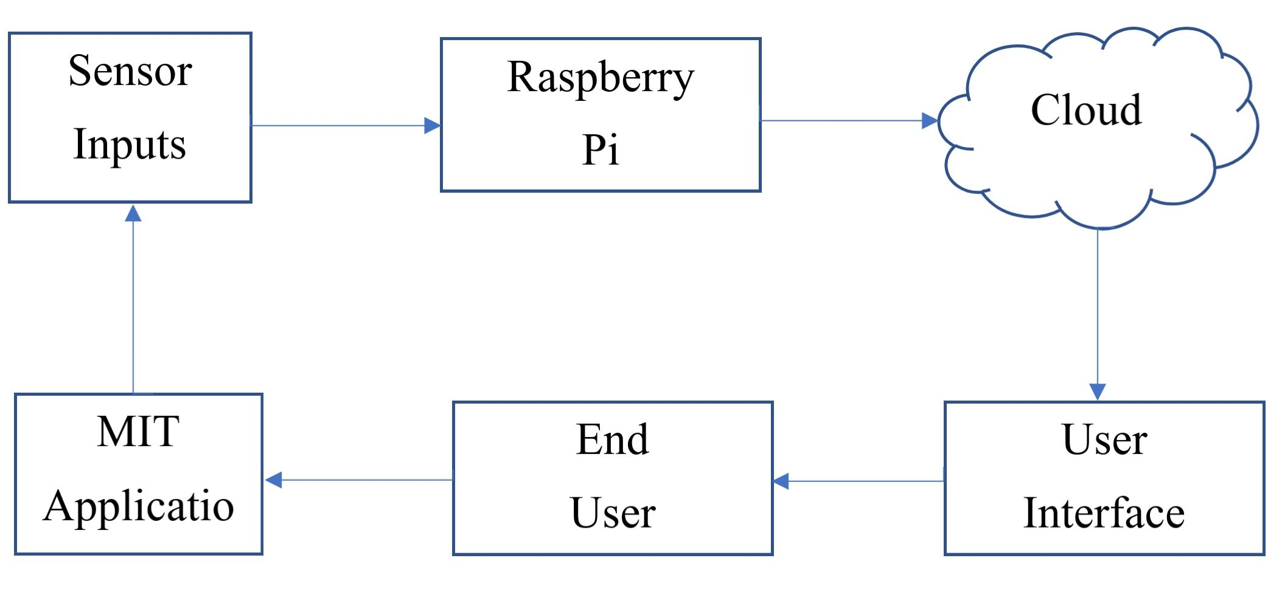

**Result:-**

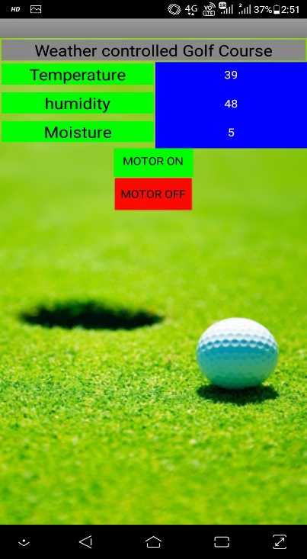One can control the turn-on & turn-off of a sprinkler at any where and any time and also it alerts the person through message based on moisture content threshold values.

**Advantages & Disadvantages:-**

***Advantages of Realtime Weather based Smart sprinkler system*:-**

* It reduces the overall water consumption. The savings can be increased further if you stop the use of the traditional spinklers and utilize the nozzles that can spray water rotating water torrents in multiple areas.
* Reduced water consumption
* No manpower required
* Require smaller Water source
* Reduce soil erosion

***Disadvantages of Realtime Weather based Smart sprinkler system*:-**

* The smart spinkler system need availability on Internet continuously. Rural part of the developing places did not fulfill this requirements.
* It requires certain skill sets in particular in order to understand. Farmers are not used to these high-end technologies.

**Applications:-**

* Used in lawns & parks
* Used Golf course & other sport stadiums
* Used in fields

**Conclusion:-**

Here a smart watering system using soil sensor and weather report has been developed. The wastage of water has been reduced by adopting weather data into the system. The problem of giving fertilizers in rainy season also has been solved. The disadvantages of time based watering system have been overcome by need based watering system, which saves gallons of water.

**Future Scope:-**

It increases more applications for more and different problems and it increases opportunities and decreases the problem.